**Test Report:**

**Login Module**

**1. Module Name:**

Login Module

**2. Objective:**

To verify and validate the functionality, error handling, input validation, and user authentication of the login module in a web-based application.

**3. Environment Details:**

OS :- Windows 10, Windows 11, Linux, Mac OS

Browser :- Chrome, Brave, Internet Explorer

**4. Test Scenarios Covered:**

1. Valid login with correct credentials
2. Invalid login with wrong username
3. Invalid login with wrong password
4. Login attempt with blank fields
5. Login with unregistered user

**5. Test Case Results:**

Test case ID :- 1

Test scenario :- login with correct credentials

Test Input :- Username :- student

Password :- Password123

Status :- Pass

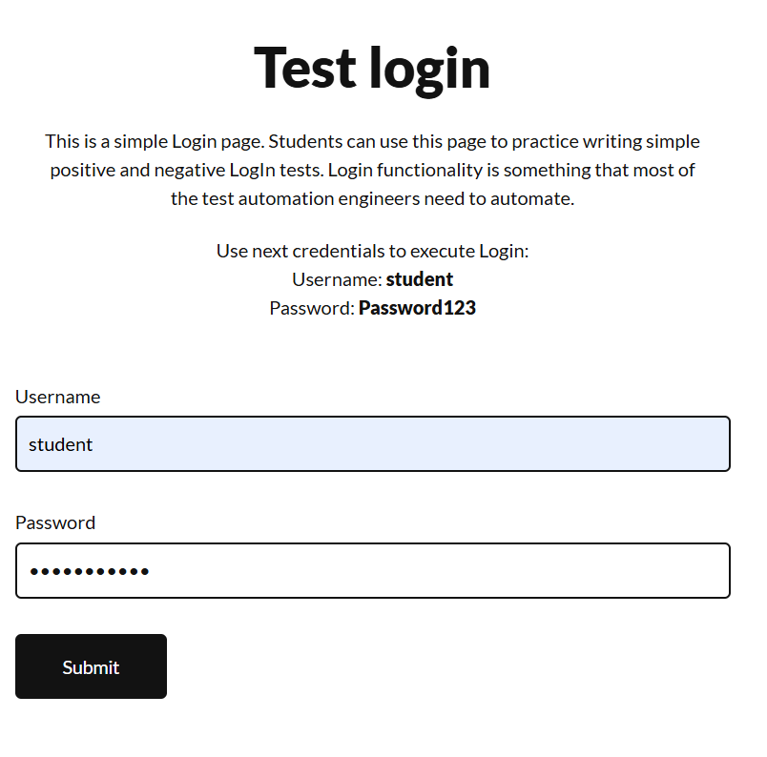  
 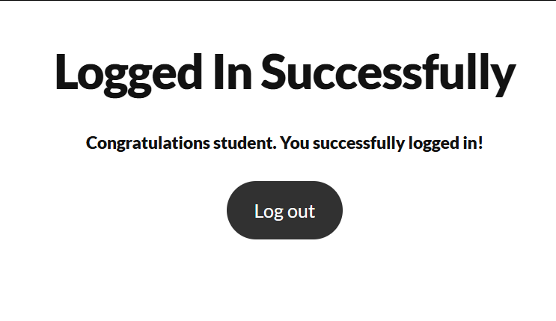

Test case ID :- 2

Test scenario :- Invalid login with wrong password

Test Input :- Username :- STUDENT

Password :- Password123

Status :- Pass

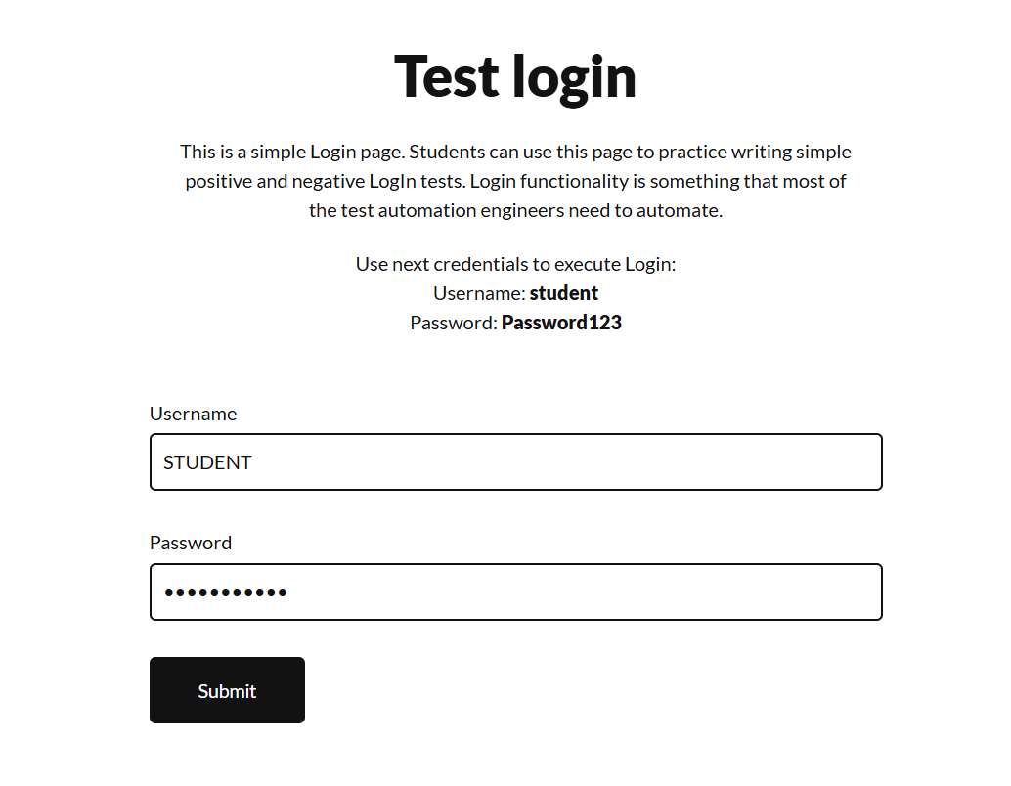

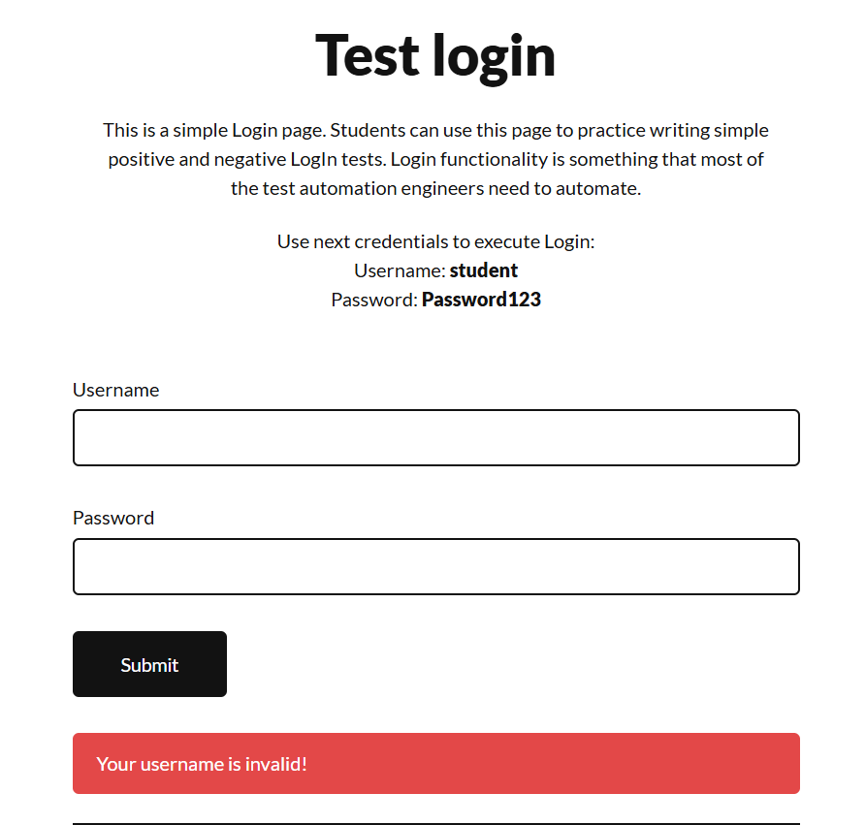

Test case ID :- 3

Test scenario :- Invalid login with wrong password

Test Input :- Username :- student

Password :- 123

Status :- Pass

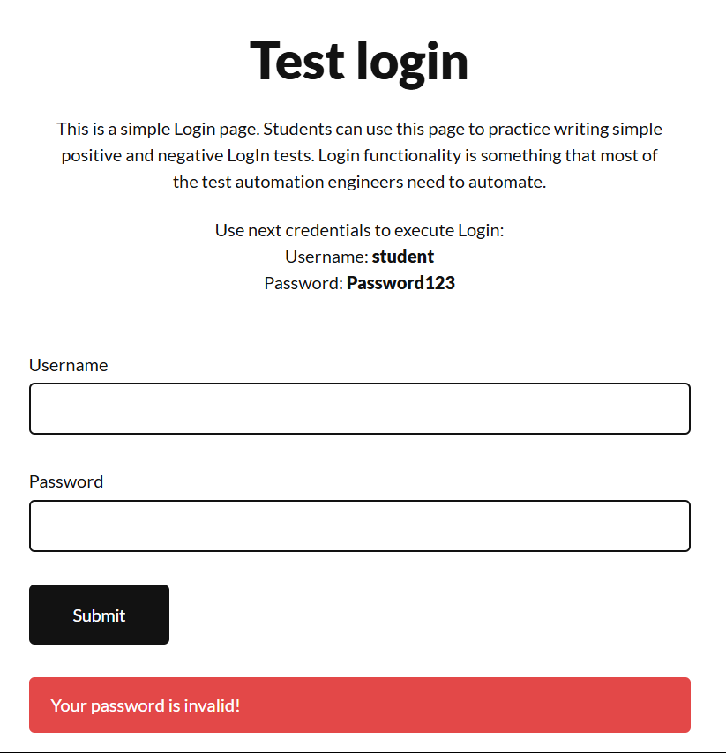

Test case ID :- 4

Test scenario :- login attempt with blank fields

Test Input :- Username :-

Password :-

Status :- Fail

Comment :- Validation required

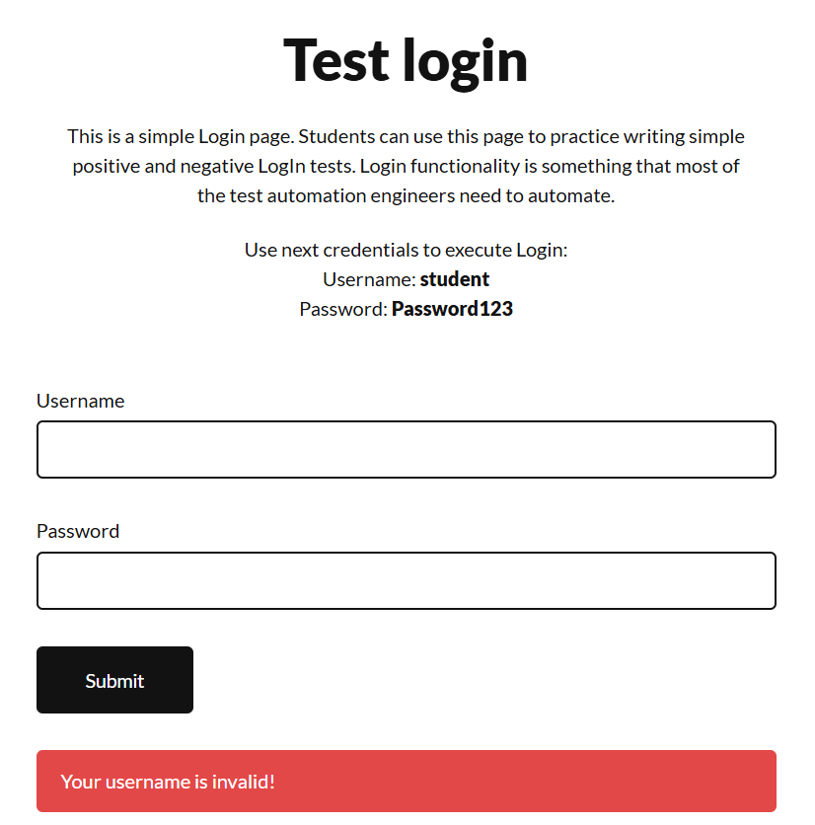

Test case ID :- 5

Test scenario :- Login with unregistered user

Test Input :- Username :- student1

Password :- Password123

Status :- Pass

Comment :- Error should be like ( Unregistered user )

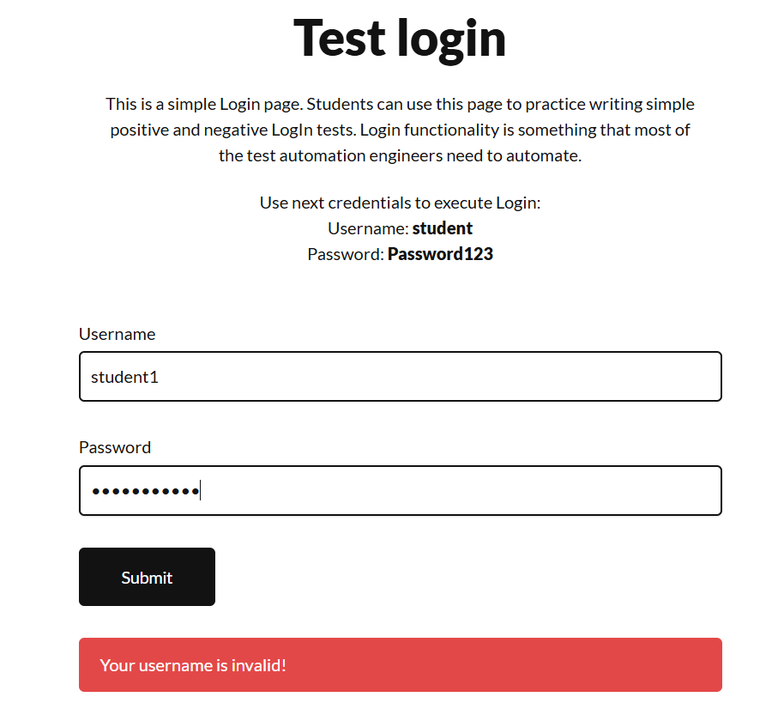

1. **Summery of Test Results :**

Total test :- 5

Passed :- 4

Fails :- 1

1. **Bug Reports :**

**Bug Report 1**

**Bug ID :**- 4   
**Title :-** No validation shown   
**Module :-** Login  
**Severity :-** Medium

**Steps to Reproduce:**

1. Go to Login page
2. Leave Email and Password empty
3. Click Login

**Expected Result :-** Show error: "Fields cannot be empty"  
**Actual Result :-** Showing error username is invalid